Lab 2

Assembly

Name: Abdelrahman Mahmoud Kamal Mahmoud Nour
ID: 39

First Program
A)

Write a program that searches for a certain byte in a string, if found, put the address of the byte in register A else, put 0xFFFFFF

Code:
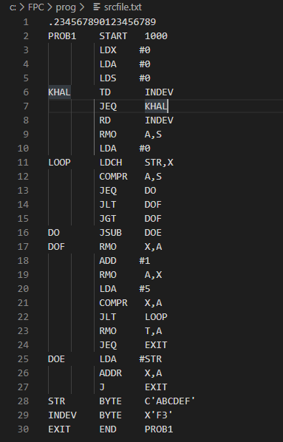

Assumptions:

1- The string is known.
2- The size of the string in known.
3- The character is read from device F3.

Sample Runs:

1-Search for character ‘C’ in ’ABCDE’
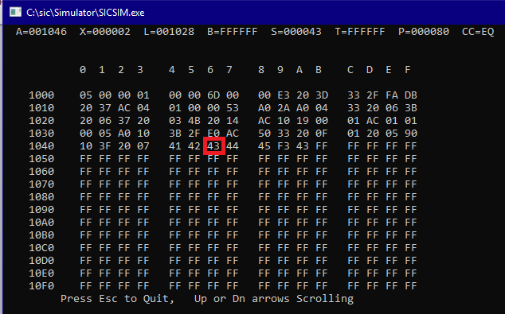
The desired character ‘C’ address is “001046” in the Accumulator which is written as “43” in hexadecimal.

2-Search for ‘c’ in ‘ABCDE’ which does not exist
Desired output in the Accumulator: FFFFFF
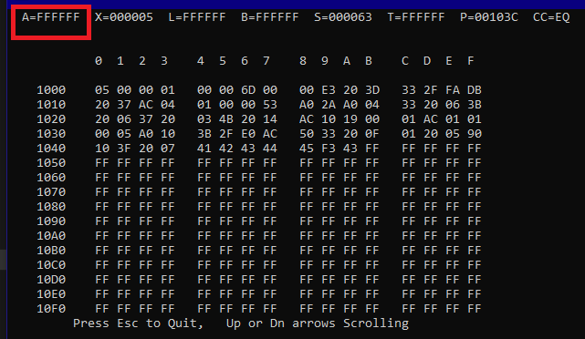

Program 2

B) Read a string from an input device and print it reversed to an output device.

Code:
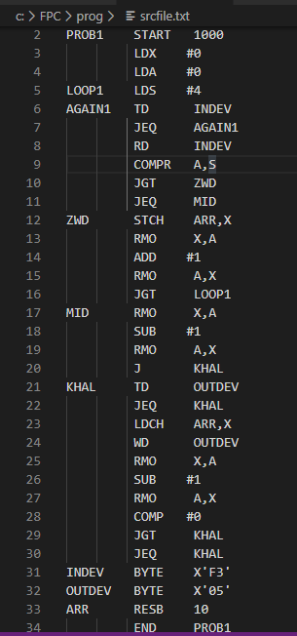

Assumptions:

1- The input is printed reversed to the output, but it is not reversed in the memory.

Sample Runs:

1- Reverse “ABCDEFGHIJ KLMNO”

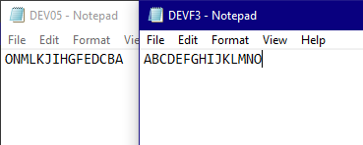
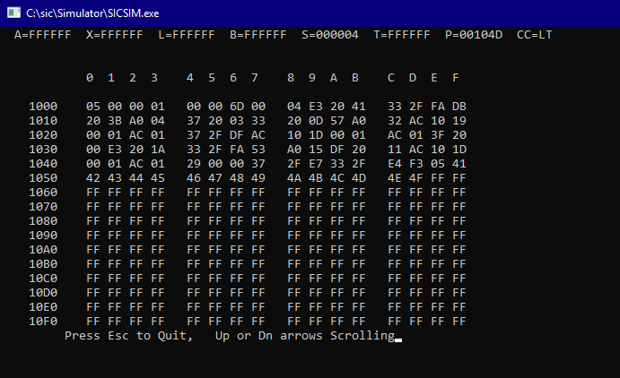

When printing the M character which is the 12th character and has index C in hexadecimal.
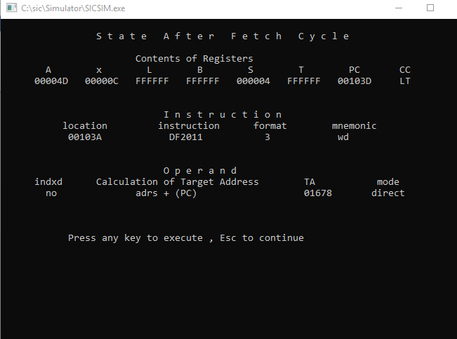

Program 3

C. Read a string from an input device and print the string to an output device after converting it to UPPER case.
(You must use at least two subroutines in this problem .One for converting a letter to an upper case. Another one for writing one character to an output device)
Code:
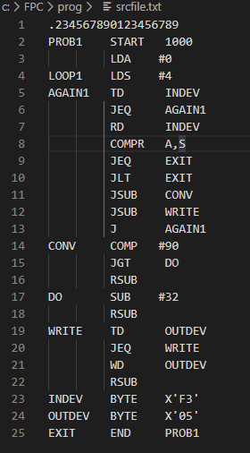

Assumptions:
No specific assumption
Sample Runs:
1- Print “abcdeeF” in upper case .
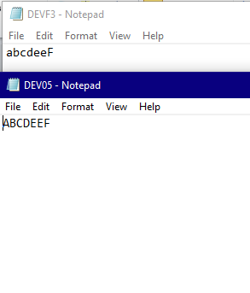
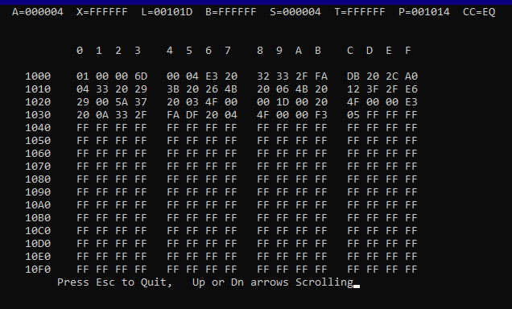

When reading “a” character and then printing it after converting it to upper case. (from 61 to 41 in hexadecimal)
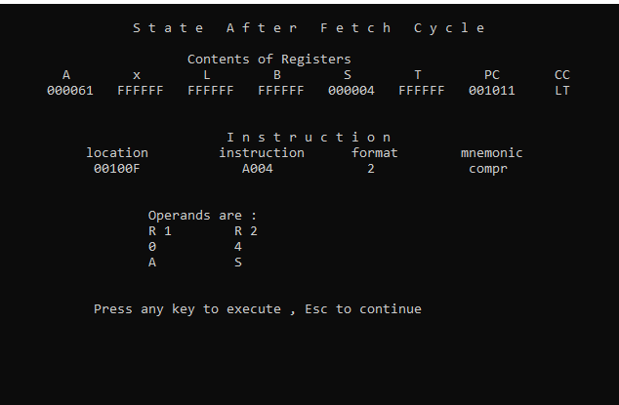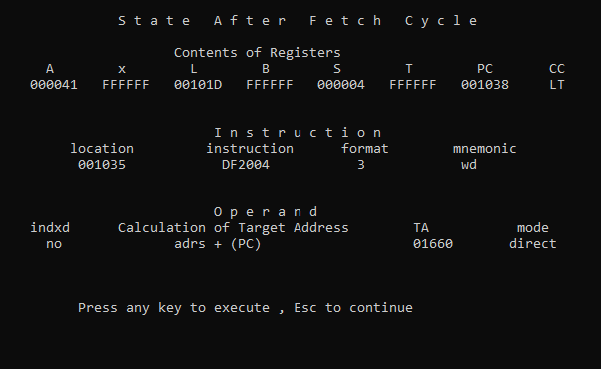
Program 4

D. Implement the bubble sort to sort characters in a string.

Code:

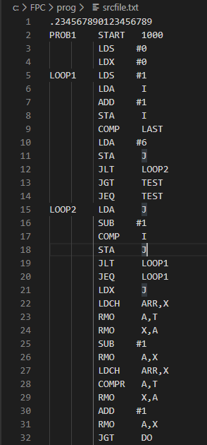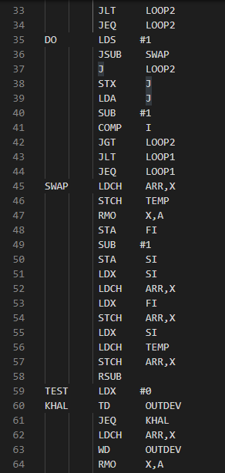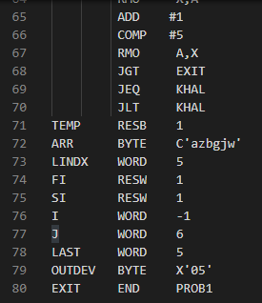

Assumptions:
1- The string and its size is known in advance and is written in the code.
Sample Runs:
1- Sort “azbgjw”
Output:
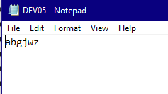
Memory Contents:
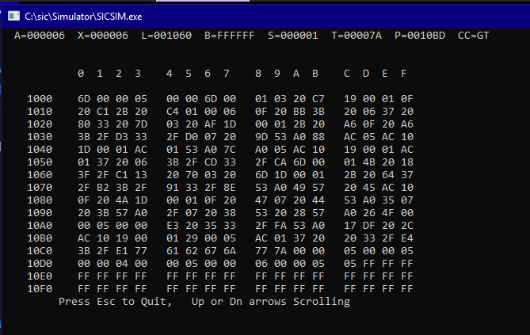
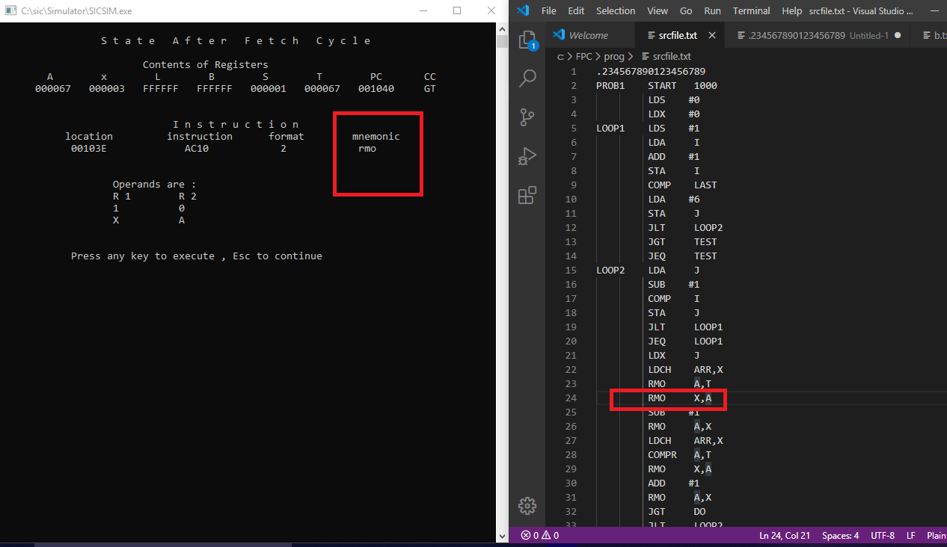

2- Sort “ABCzxy”

